% Concentration / ppm / Dilutions – Checkpoint quiz NAME _______________________________
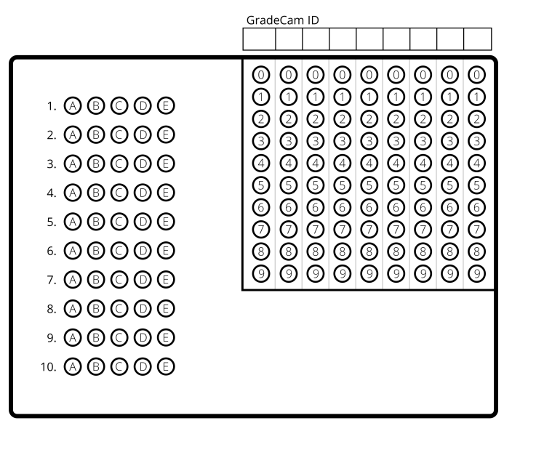
- How many grams of NaOH are in 210 mL of a 4.5% (mass/volume) solution of Drain-O?

- What is the percent concentration (mass/mass) of 10 grams of sugar dissolved in 900 grams of water? [Remember: add your sugar & water mass together!]

- You dilute 20 mL of bleach in 3 liters of water, to sanitize your toilet. What is the % (volume/volume) of bleach in your cleaning solution?

- You want to make 100 mL of a 20% salt (NaCl) in water solution. Which of these formulas would be most appropriate to use?
  - % mass/mass (%m/m)
  - % volume/volume (%v/v)
a. 0.0066%
b. 0.01%
c. 0.67%
d. 1.10%
e. 1.11%
ab. 6.6%
ac. 0.21
ad. 0.32
ae. 0.44
bc. 0.57
bd. 1.75
be. 2
cd. 6.55
ce. 9.45
de. 20
- 46.6
- 48
- 50
- 112
- 200
ab. 945
ac. 2000
ad. 2000
  - % mass/volume (%m/v)
  - % molarity (%moles/v)

- How many grams of salt are needed to make the solution in #4 above?

- The average American has 8 ppm of pesticide in their fat tissue. If you have 14 kg of fatty tissue in your body, how many mg of pesticide do you contain?

- Kennecott Copper discharges 4 liters of 40,000 ppm toxic waste into an overflow tank containing 500,000 liters of water. What is the final concentration of toxic waste?

- How many milliliters of a concentrated 3 M H2SO4 acid need to be diluted to make 1.5 liters of a 4 M H2SO4 solution?

Dilution problems:
- Multiply the pair
- Divide by the loner

